**LED FLASHER**

**CIRCUIT DIAGRAM:-**

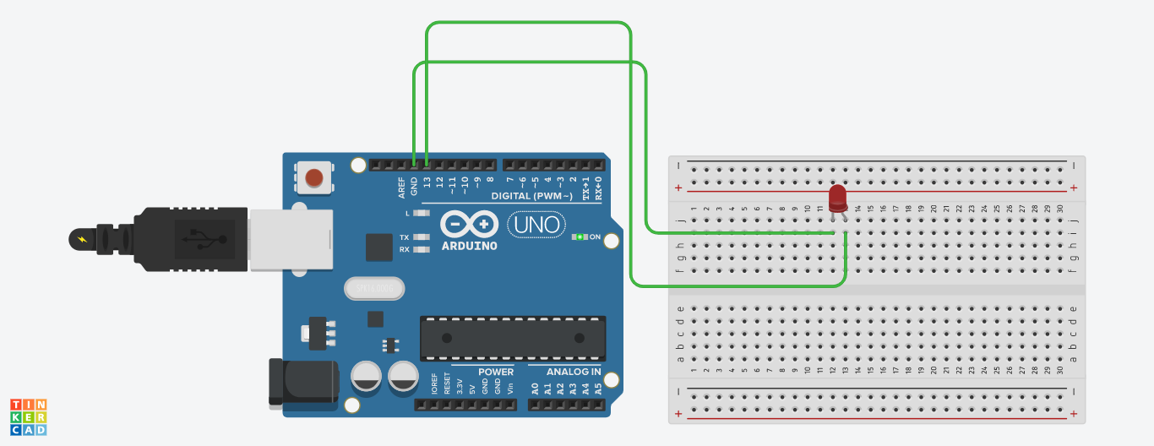

**THEORY**

**CONCEPT USED:-**

Here we will use the concept of multimeter, breadboard, arduino UNO, LEDs and connections. We have connected positive terminal of LED with pins in arduino UNO and negative terminal is grounded. Also codes were made to run the program.

*OHM’S LAW:-*

It states that current through a conductor is directly proportional to the voltage across the two points provided that the physical condition such as temperature remains constant.

**V=IR**

**LEARNING AND OBSERVATION:-**

1. Blinking of one LED was observed after an interval of 500 milliseconds on uploading the program.
2. We observed that firstly, one LED glow and then the LED goes off after every 500ms.
3. Code was written accordingly so as to run the program.

**PROBLEMS AND TROUBLESHOOTING:-**

The problem faced while performing the tasks were:-

1. The connections went wrong so I had to change the connections and that’s why LED was not blinking.
2. LED used was damaged that’s why it wasn’t glowing.

**PRECAUTIONS:-**

1. Double check the circuit and breadboard diagram to make sure all the components in the right place.
2. Hands should not be wet while working with the circuits to prevent shock.
3. The circuit must be closed and neat.

**LEARNING OUTCOMES:-**

1. I learned that how we work with Arduino UNO and breadboard and how to make connectionsto start the blinking of LEDs.
2. I learned making circuits using different hardwares and controlling the functions done by circuit with the program.
3. I learned to make codes for the simulation of arduino UNO.